INDUCED MAGNETISM
- Definition:
Induced magnetism is the property by which a magnetic material becomes a temporary magnet when it is brought near a magnet.
- Key Points:
- Induced magnetism is usually temporary.
- It occurs in magnetic materials such as iron, nickel, and cobalt.
- The object becomes magnetized because of the nearby magnet.
- When the magnet is removed, the induced magnetism decreases or disappears.
- Different Ways of Inducing Magnetism:
- By Bringing a Magnet Near It (Magnetic Induction)-
When a magnet is brought close to an iron object, the object becomes a temporary magnet.
No touching is required.
Example: An iron nail attracts pins when a magnet is held near it.
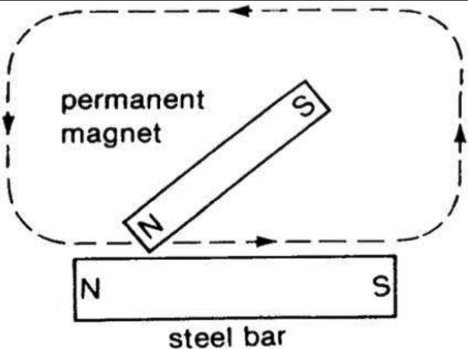
- By Stroking (Touch Method)-
A magnet is rubbed in one direction along an iron needle or steel bar several times.
The object gradually becomes magnetized.
Example: Making a sewing needle act like a magnet by rubbing it with a bar magnet.

- By Electric Current-
Passing electric current through a wire wound around an iron core makes it magnetic.
Such a temporary magnet is called an electromagnet.
Example: Electric bells and cranes used to lift scrap iron.

